Report of Data Compression

In the decompress part, we first get familiar about how to read and write an image into the cloud point, and check the structure of it, which is composed by three planes(xy,yz,zx): xy: [0 400][0 1000], yz: [0 1000][100 500], zx: [0 400][100 500]

Then, we try to get the three projections of it from three directions respectively:

front:[0 90];

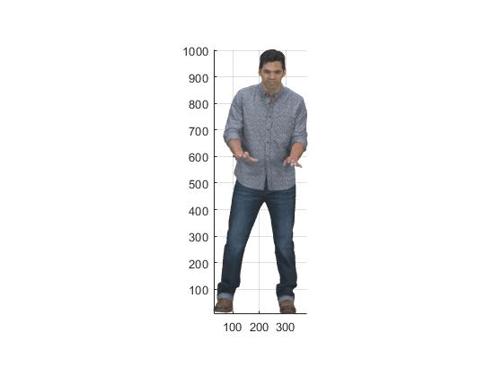

top: [0 180]

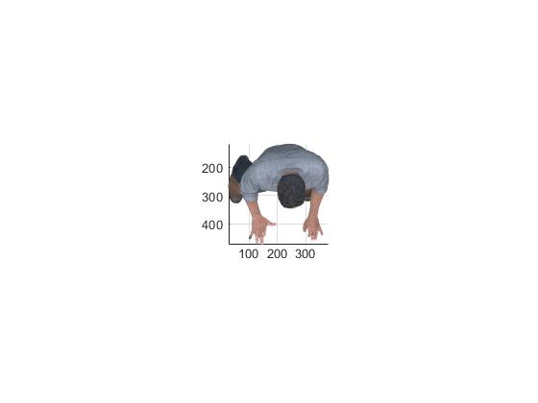

and right [90 0 ]

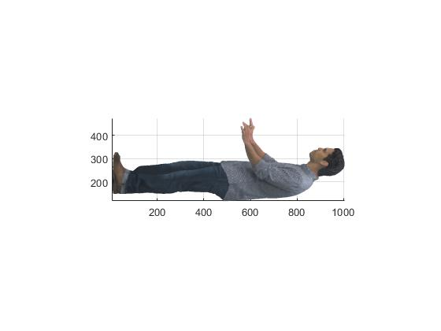

Use its geometry and color information, we then save the extraction of the top/bottom projection,

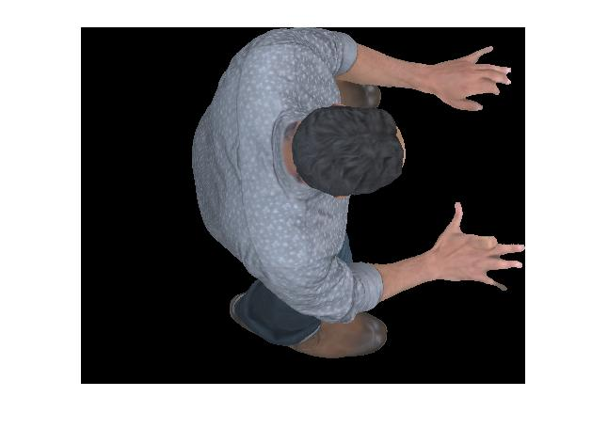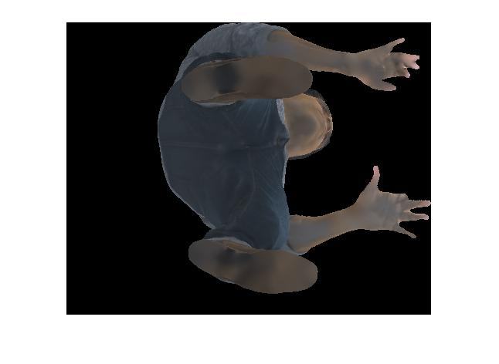

Last, we try to converse the top one into the grey scale:

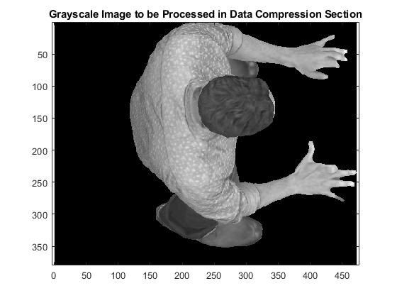

Plot the histograms:

Histogram of the top :

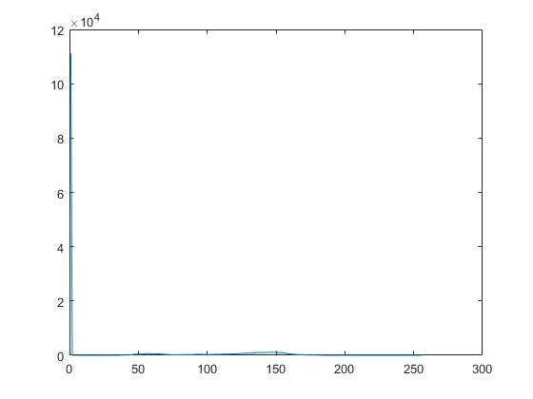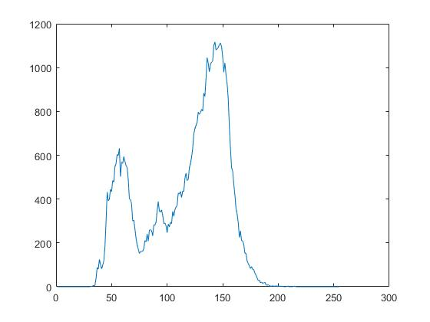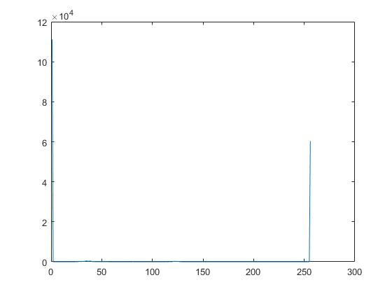

Histogram of the bottom:

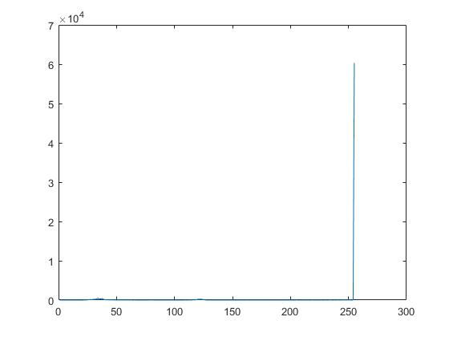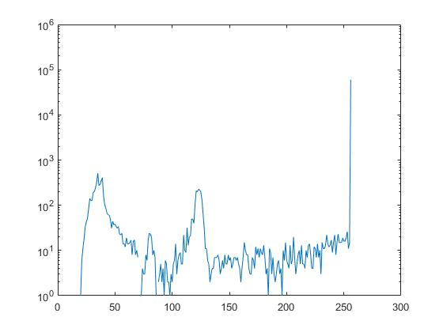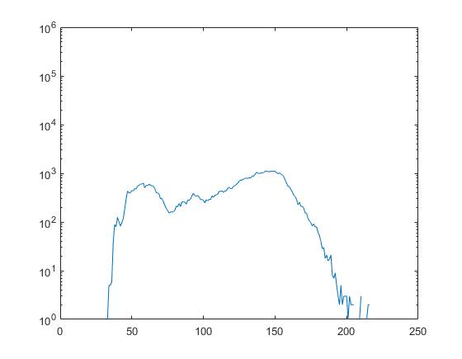

For the decompression, first we calculate the entropy of the A by :

1. get the pk of each gray level:

[counts,binLocations] = imhist(A);

p = counts/sum(counts);

1. calculate the entropy: Entropy = -sum(nonzeros(p).\*log(nonzeros(p)));

Then we get the residule matrix E with e,w,ne,nw by

1. set the first column and first row:

for c = 2:columns

E(1,c) = median([0,E(1,c-1),E(1,c-1),E(1,c-1),E(1,c-1)]);

end

for r = 2:rows

E(r,1) = median([E(r-1,1),0,E(r-1,1),E(r-1,r)\*((E(r,r+1)-1)),E(r,r+1)\*E(r-1,r)/2]);

end

1. Finally get the whole matrix E
2. Plot the E:

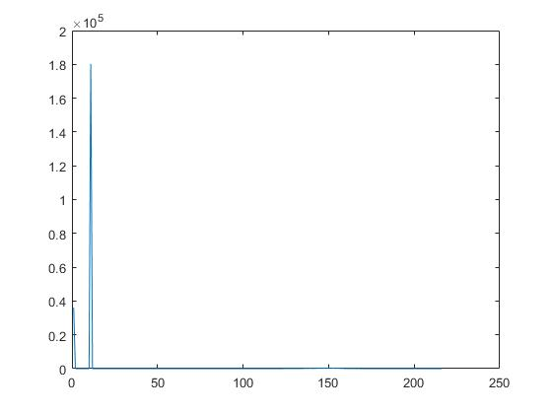

THrought rh Golomb-Rice step, we try to get the binary value of the matrix A(Input: block size: b, origin figure matrix A)

1. get the p by minimum the length of the word:

For every block, which is of size b\*b, use the value p to show the block. The value p is achieved by minimizing the gr criteria

for h = 1 : b : H

for w = 1 : b: W

for t = 0 : 8

p=min(min(1+t+A(w:w+b,h:h+b)/2^t+1));

A(w:w+b,h:h+b)= p;

end

end

end

Unfortunately, the result went wrong:



Thus, I also did not further to the binary translation.

Improvement:

Noise might be processed in advance. For instance, we can use the average operator to deal the value for each block before we conduct the GR. The block size can be chosen.

10110032 Qin He